**Characters**

**The Story of the HAKA**

1. Te Rauparaha was the chief of Ngati Torangatira.

2. He visited Tuwharetoa to get aid against the Waikato tribe, but was refused due to his actions in the past.

3. Still seeking aid, Te Rauparaha followed the forest track to seek refuge with Te Wharerangi.

4. Te Wharerangi, although hostile towards Te Rauparaha, felt obliged to give some protection against the taua (war party) led by Tauteka.

5. He told Te Rauparaha to seek refuge in an empty kumara pit nearby, and asked his wife, Te Rangikoaea, to sit over the entrance to the pit

6. As the persuing party approached they chanted incantations to put a spell on Te Rauparaha, but he stayed crouched in the pit.

7. In addition to protecting Te Rauparaha, Te Rangikoaea being a woman, acted as a neutraliser to the effects of the spells being cast on him.

8. When the pursuers arrived, they asked Te Wharerangi whether he’d seen Te Rauparaha, and he told them he had fled into the desert. Te Rauparaha muttered to himself, “Aha ha! Ka mate, ka mate!” (I die, I die!)

9. At first, Tauteka didn’t believe Te Wharenangi, but soon hurried off toward the desert.

10. Once Te Rauparaha realised he was safe he exclaimed, 'Ka ora, ka ora! Tenei te tangata puhuruhuru nana nei i tiki mai whakawhiti te ra!' ('I live, I live! For this is the hairy man who has fetched the sun and caused it to shine again!)

11. As he took his first steps out of the pit, he said, 'hupane, kaupane!' and as he stood clear he shouted, 'whiti te ra!' ('The sun shines!')

**Scene Descriptor**

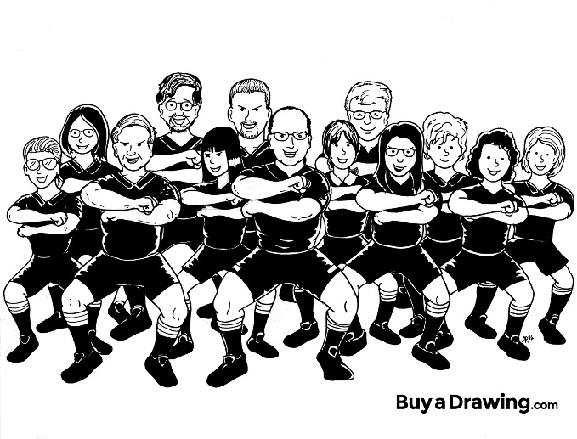

**Group Members:**

**4 Components of a Script**

*

*

*

*

**HAKA Lyrics**

A Ka mate! Ka mate! Ka ora! Ka ora! *(I die! I die! I live! I live!)*

Ka mate! Ka mate! Ka ora! Ka ora! *(I die! I die! I live! I live!)*

Tenei te tangata puhuru huru *(This is the hairy man)*

Nana nei i tiki mai *(Who fetched the Sun)*

Whakawhiti te ra *(And caused it to shine again)*

A upa ... ne! ka upa ... ne! *(One upward step! Another upward step!)*

A upane kaupane whiti te ra! *(An upward step, another.. the Sun shines!!)*

Hi !!

**Script Example**

*The drawing room of Lady and Lord Montague, which is furnished with plush carpets, silk curtains and beautifully carved antique furniture. Lord Montague is sitting on a velvet sofa, smoking a pipe and reading the paper. Lady Montague is sitting at a grand piano, trying but failing to play a melody.*

**Lady Montague:** Try as I might, I simply cannot get this blessed melody right!

**Lord Montague:** You are trying too hard, darling. Relax, look at the notes and let your fingers find their way to the right notes. Stop trying to get it right. Just feel the music.

**Lady Montague:** *(pushing a strand of hair from her face wearily)* Yes. Perhaps you are right.

**Computer Layout**

1. Begin with a short scene descriptor written in *italics*

2. Start a new line each time a new character speaks

3. Put the name of the speaker on the left, in **bold**, followed by a ‘:’

4. Use the ‘tab’ button to make even gaps between the character name and the dialogue

5. Write character actions in brackets and *italics*

6. If the scene changes, write a new scene descriptor